Population: Population Growth
In demographics, the world population is the total number of humans currently living, and was estimated to have reached 7.7 billion people as of April 2019. It took over 300,000 years of human history for the world's population to reach 1 billion; and only 200 years more to reach 7 billion.

Early humans: Genetic measurements indicate that the ape lineage which would lead to Homo sapiens diverged from the lineage that would lead to chimpanzees and bonobos, the closest living relatives of modern humans, around 4.6 to 6.2 million years ago. Anatomically modern humans arose in Africa about 300,000 years ago, and reached behavioural modernity about 50,000 years ago.

Population geographers have traditionally been concerned with the analysis of trends and patterns of growth in world population. However, lack of reliable data on size of population during early times rendered their task very difficult. It may be recalled that the first census operation began in a few countries of Europe only in the beginning of the nineteenth century, and as late as the middle of the twentieth century, several countries of the world had never conducted any census. Even at present times, reliable estimates are not available for most of the regions in the less developed parts of the world. Despite this limitation, several attempts have been made to chart the trends and patterns of the world population growth using some indirect evidences. These indirect sources include archaeological remains and for more recent periods, written records and estimates based on survey of different kinds. These estimates help us construct trends in world population growth in the past and identify its spatial patterns.

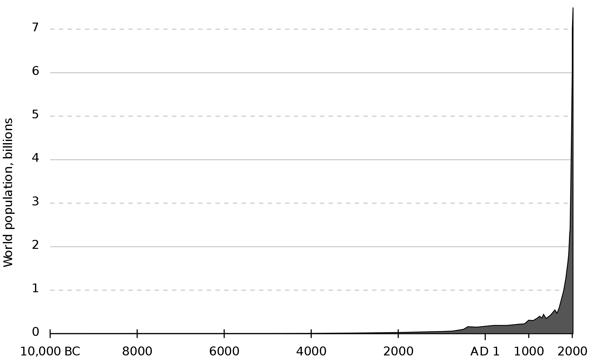
Past Trends in World Population Growth
For most of the human history, the size of world population, in general remained very small and virtually stagnant due to extremely high death rates. The present rate of growth in population is, thus, a recent phenomenon. Rates of growth in population over a long time in human history remained very small, and occasional decline in numbers, due to such events as wars, epidemic and famines, was a common phenomenon.
The history of growth in world population is marked by three distinct periods of sudden acceleration in growth rate –
- Around 8000 BC
- 1750 AD
- Since 1950
The period around 8000 BC is said to be a turning point in human history when man learnt the art of domesticating plants and animals. With this development, he was no more a food gatherer or a hunter. Rather, he became a food grower himself. Likewise, the year 1750 is marked with revolutionary changes in economic systems generated by, first agricultural revolution and then industrial revolution, in Europe, which in turn, unleashed profound changes in demographic trends. Finally, the middle of the twentieth century coincides with the onset of demographic expansion in the less developed parts of the world, as a result of the spread of medical technology. Thus, each of these periods of sudden spurt in the growth rate is linked with technological advances, which increased the capacity of the earth to support human populations.
Population Growth by the billions
It is estimated that the world population reached one billion for the first time in 1804. It was another 123 years before it reached two billion in 1927, but it took only 33 years to reach three billion in 1960. Thereafter, the global population reached four billion in 1974, five billion in 1987, six billion in 1999 and, according to the United States Census Bureau, seven billion in March 2012. The United Nations, however, estimated that the world population reached seven billion in October 2011.
According to current projections, the global population will reach eight billion by 2024, and is likely to reach around nine billion by 2042. Alternative scenarios for 2050 range from a low of 7.4 billion to a high of more than 10.6 billion.

World Population Growth in Billions (USBC Estimates)
Population | 1 | 2 | 3 | 4 | 5 | 6 | 7 | 8 | 9
Year | 1804 | 1927 | 1960 | 1974 | 1987 | 1999 | 2012 | 2027 | 2046
Years Elapsed | - | 123 | 33 | 14 | 13 | 12 | 13 | 15 | 19

Growth Differentials
One of the salient features of growth in the world population during the recent past has been its uneven pace between different regions and countries. Though the rates of growth have varied over space throughout human history, the differential growth during the last half a century or so has been more conspicuous. The most important dimension of this uneven growth in world population is the contrasts between the developed and less developed regions of the world. Between 1950 and 2000, nearly 90 per cent of the net addition of 3.4 billion people in the world population came from the less developed regions. The contribution of the less developed regions happened to be still higher towards the close of the twentieth century and later. For instance, during 1995-2000, less developed regions contributed as much as 97 per cent of the net increase in the world population. The UN projections indicate that the less developed regions will account for the whole of the net increase between now and 2050 because the developed regions will experience overall decrease in their populations.
This unevenness in the growth rate is reflected in the shift in the distribution of population among different regions, countries and continents during the recent past. While Europe and North America have witnessed a steady decline in their share inn the world population, Africa, Latin America and Asia have recorded an increase in their share. In 1950, Europe and North America had accounted for 28.5 per cent of the world population, which came down to 17.6 per cent in around 2000. If other developed countries like Japan, Australia and New Zealand are also included, the share of the more developed regions is reported to have declined from over 32 per cent in 1950 to barely 20 per cent in around 2000. According to the medium variant projection of the UN, their share will further decline to 13 per cent by 2050. Meanwhile, the share of Africa in the world population has gone up from 8.8 per cent to12.7 per cent during the same period and is projected to reach 19.8 per cent in 2050. The population of Africa that was less than half the size of that of Europe in 1950 surpassed the latter in the mid-1990s. Latin American countries presents another case of disproportionate concentration of growth in population. In Latin America, the share is found to have gone up from 6.62 per cent in 1950 to 8.54 in around 2000. However, it is expected that its share will register a decline, albeit marginally, by the middle of the present century. Though, continuing as the main contributor in absolute terms, Asia’s net addition of population is likely to be 1.7 billion during 2000-2050 as compared to 2.18 billion during 1950-2000.
Population growth rates at individual country levels vary further. It is interesting to note that almost whole of Eastern Europe and Asiatic Russia are experiencing decline in population size. These populations are marked with more deaths than births annually – a phenomenon that is not occurring elsewhere in the world.
On the other extreme are African countries marked with persistently very rapid growth in their populations. Barring a few countries, almost the whole of Africa still reports a natural growth rate of over 2 percent annually. Some countries are even growing at a rate of more than 3 per cent per annum. The Islamic countries in Asia also report growth rates of same magnitude. It is worth mentioning here that in all these countries death rates have undergone sharp decline during the recent past while birth rates continue to be very high. A major part of the growth, thus, results from high levels of natural increase in the wake of high birth rate and youthful age structure.

