Agricultural Resources: Plantation (Tea) in NER
North East India has favourable physical conditions for tea. This plant needs a high average annual temperature of more than 25° C. Ground should be gently sloping for water to runaway quickly. The soil should be acidic. Further, the winter drought should not be long. All the conditions are fulfilled by the foothill regions of North East India and the slightly undulating grounds of the upper Brahmaputra Plain, Barak Plain and Tripura Plain. It is, therefore, found that North East India produces more than 2/3 of the total production of India. In fact, Assam alone produces more than 20 % of the world’s tea.
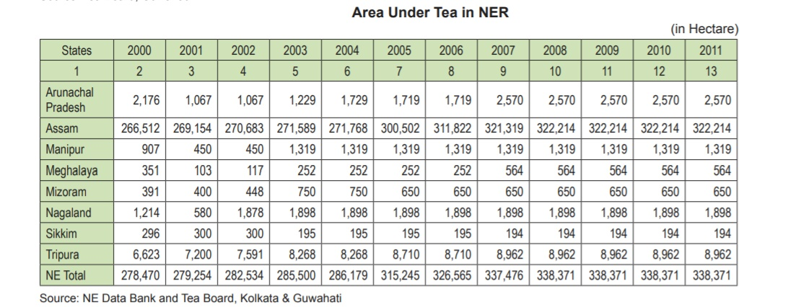
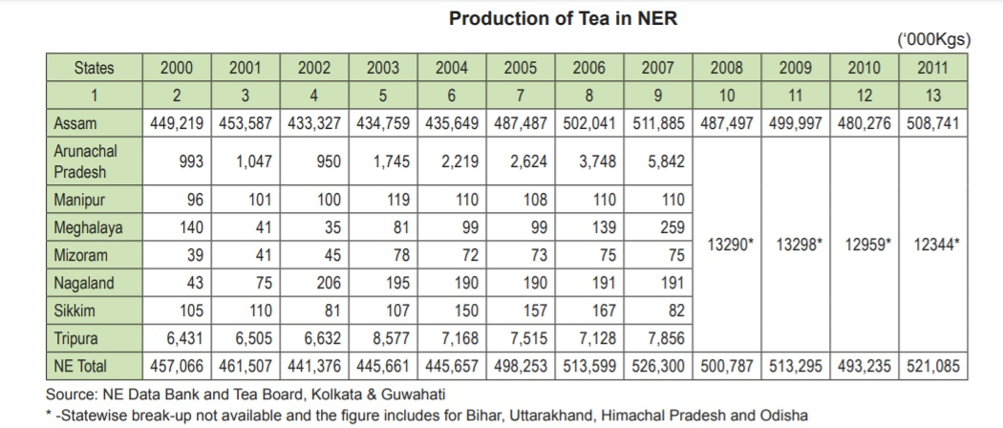

Of all the states in India, Assam produces the largest quantity of tea and has largest area under this crop. In 2011, the state had 322,214 ha of land under tea plantation and produced 508,741, 000 kgs of tea, which is 95 % of the total tea area and 97 % of the total tea production of the area. In Assam tea is grown both in the Brahmaputra and Barak Plains. In the Brahmaputra Plain tea gardens are located mainly in foothill regions, higher areas occupied by old alluvium and over the relatively higher undulating plains protected from inundated plains. Tinsukia, Dibrugarh, Sibsagar, Jorhat, Golaghat, Nagaon and Sonitpur are the districts where tea gardens are frequently found. Besides, Darrang, Lakhimpur, Kamrup and Kokrajhar districts also have some tea gardens. The Barak Valley tea gardens are located along the foothills and on the isolated hillocks (tillas) scattered in the Plain. Compared to India as a whole, Assam with 322,214 ha of land accounted for more than 50 % of the total land under tea in the country. It is found that the area under tea has not been increasing substantially of late.
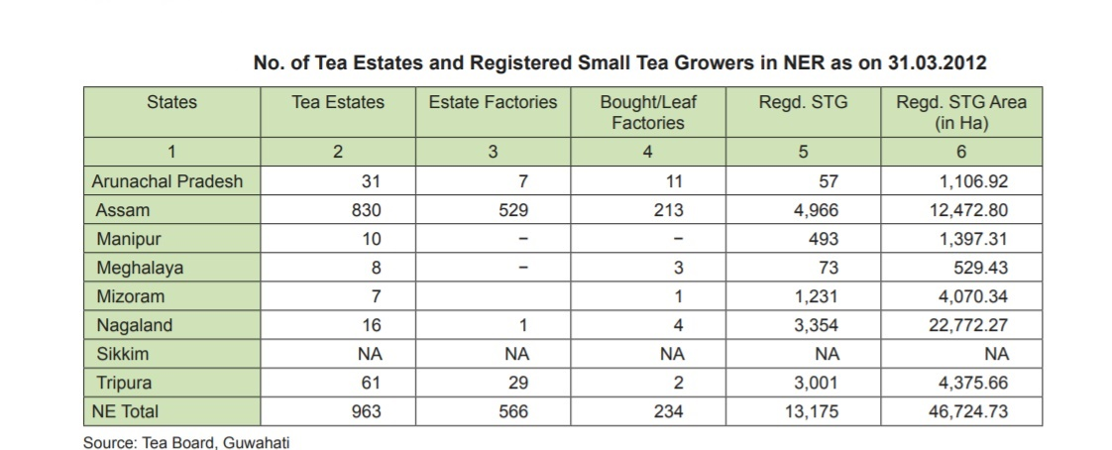
As per the Tea Board, Guwahati, there were altogether 5796 (830+4966) tea gardens in Assam in 2012. Out of these about 830 are large. The remaining gardens are small and started mainly by local young entrepreneurs. These gardens produced 508,741, 000 kgs of tea in 2011. The yield per hectare 1593 kg in 2007.
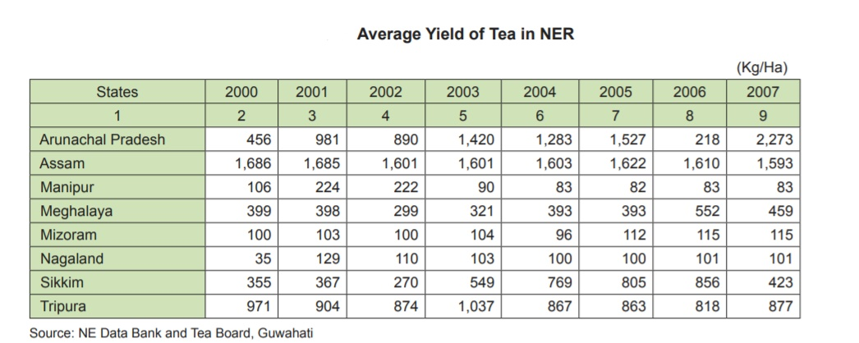
The number of tea gardens, number of factories, area occupied, production and yield increased from 1961 to about 1990 significantly. This development has been possible because of more scientific growth of tea, use of fertilizer, opening of new gardens and expansion of old ones and above all, increasing demand of the beverage in the national and international market. Today, Assam has about 619,743 labourers employed in tea plantation (2006), a major subsector of employment in the primary sector of the economy.
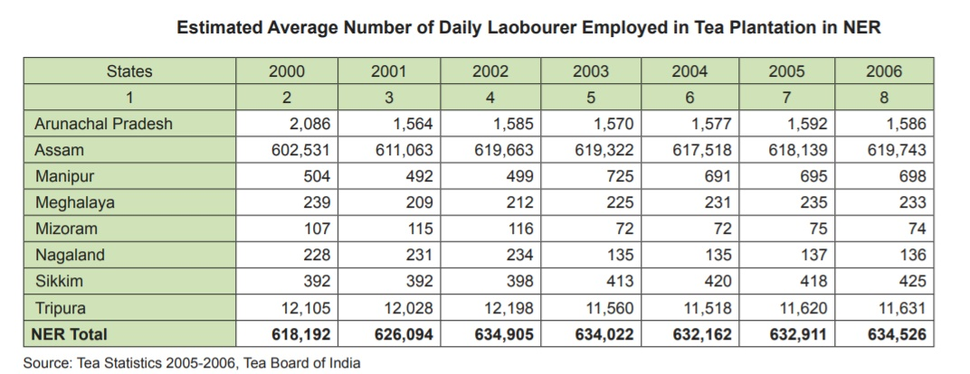
Tripura comes next to Assam in production of tea with 61 large tea gardens, spreading over 6.5 thousand hectares of land. The tea produced in Tripura is also of good quality. In 2011 it had 8,962 ha of land under tea cultivation produced about 7856, 000 kgs of tea (the data is though for 2007, but in 2011 too the production should be around that figure because the trend of growth of the industry in the state has not been encouraging). The lack of growth of the industry is due to transport bottleneck and labour problem. If these difficulties are overcome, the state with its ideal climate, topography (with low gently sloping hills) and soil shall be able to prosper in tea plantation.
Since tea plants were first found in the foothills of Lohit district of Arunachal Pradesh, the state especially its eastern foothills are ideally suitable for the crop. Experimental tea plantations was started in the state in Deomali in Tirap district. The individual farmers of Ingkiang Sub-Division of East Siang district have also started tea plantation over about 1000 ha of land in small family gardens. A large tea garden at Oyang near Pasighat with 600 hectares of land has already come up. This garden is trying to grow Darjeeling variety of tea also. The state has taken up an ambitious plan to grow tea at the cost of Rs. 6.4 crores and it is likely that the state will soon find place in the tea map of India.
Mizoram has been growing an indigenous variety of tea for domestic use since long. In fact, it is found that as many as 2,098 families grow tea on their small orchard gardens over 1000 ha of land for their domestic use after an indigenous method of processing. The Soil Conservation Department of the state has of late, been concentrating on growing tea. Tea gardens are mostly concentrated in the northern foothills of the state bordering Cachar.
The climate and soils of Meghalaya have been found to be suitable for tea cultivation. In fact, a few small experimental plantations were started in the state about a decade ago. It is found that the tea grown in such experimental gardens at Umsning, Rariyangdo and Tobrungiri is of excellent quality and its yield is also encouraging.
Nagaland has also started tea cultivation in the state but their contribution is insignificant to total production of the region. Manipur has little organized tea plantations.

