THE SIGNIFICANT STAGES IN THE DEVELOPMENT OF THE MODERN OLYMPIC MOVEMENT
- From the beginning, the modern Olympic Games have become a major international event, and this attention has changed the games several times.
- The Modern Olympic Movement is governed by the International Olympic Committee (IOC), based in Lausanne, Switzerland. The Modern Olympic Movement includes the summer “Games of the Olympiad” (an Olympiad designates a four year period between the Games) and Winter Games. The word “movement” conveys the fundamental principles of the International Olympic Committee and the Olympic Movement.
- At its core, the Olympic Movement is built on the philosophy of strong ethics, human rights, and peace. These are among the principles of “Olympism.” These principles, along with other rules and by-laws are officially codified by the Olympic Charter. This charter “governs the organization, action, and operation of the Olympic Movement and sets forth the conditions for the celebration of the Olympic Games.” The Olympic Charter functions as the IOC’s constitution and statutory authority.
- The composition of the Olympic Movement, of which the Olympic Games are a part of, consists of the following organizational elements:
- International Olympic Committee
- International Sports Federations
- National Olympic Committees
- Organizing Committee for the Olympic Games
- National Associations and Clubs
- Judges, Referees, Coaches, Sports Personnel
- Other recognized Organizations
- The International Olympic Committee, founded by Baron Pierre de Coubertin in 1894, is the non-governmental organization responsible for the Olympic Movement, of which the Games are a part of. The IOC has the primary responsibility of supervising the Olympic Games. The IOC is governed by a President, who serves an eight year term; an Executive Board consisting of the President, four Vice-Presidents, and ten other members; and Members who are representatives of the IOC in their respective countries.
- In 1900, the committee broke from Greek traditions and allowed women to compete. In 1912, they started hosting art, literature, and music competitions to mirror the Greek value of art and athleticism as two parts of ideal human achievement. The cultural programs and highly-advanced opening and closing ceremonies are tributes to this.
- In 1924, the Olympics were expanded to include winter sports, and 1928 saw the first presentation of the Olympic flame, a tradition with no actual Greek precedent. Throughout the 20th century, the games changed with the times, but they also grew in importance.
1. Ideals of Modern Olympic Games:
- Sport not just as a physical activity but also as a means of educating people.
- The good sportsmanship, sense of fair play, and respect for fellow athletes that is developed through participation in sports teaches men and women of different races, religions, and nationalities to work peacefully together in competition toward common goals. The Olympic Movement works to expand such lessons beyond the sports arena in the hope of promoting peace and a sense of brotherhood throughout the world.
2. Motto of Modern Olympic Games:
- The Olympic motto consists of the Latin words Citius, Altius, and Fortius, which means “Faster, Higher, and Stronger”. The motto, introduced in 1924, is meant to spur the athletes to embrace the Olympic spirit and perform to the best of their abilities.
3. Rings of Modern Olympic Games:
- The official symbol of the modern Olympic Games is five colored rings linked together. These rings represent the continents of North and South America, Africa, Asia, Australia, and Europe. They also symbolize the uniting of athletes from all over the world to compete at the Olympic Games. The Olympic flag, first used at the Antwerp Games in 1920, has the Olympic symbol in the center of a white field.
4. Flag of Modern Olympic Games:
Olympic Flag
- The Olympic flag was created by Pierre de Coubertin in 1925.
- The Olympic flag has a white background, with five interlaced rings in the centre: blue, yellow, black, green and red. This design is symbolic; it represents the five continents of the world, united by Olympics, while the six colours are those that appear on all the national flags of the world at the present time.
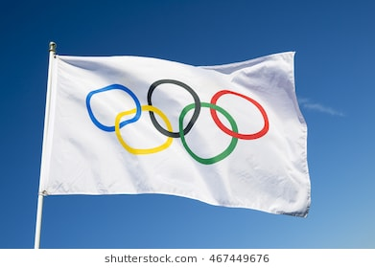
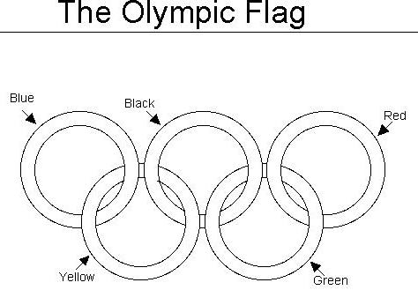
Ceremonial Flag
- This flag is made of Silk.
- This is bordered with five colours of the rings representing five continents.
- The colours are blue, yellow, black green and red.
- The flag is not used for hoisting purposes.
- The flag is handed over to Mayor of the city by the president of the International Olympic Committee at the time of closing ceremony. This flag shall be under the custody of the Mayor of the city till the next Olympic.
5. Emblem of Modern Olympic Games:
- Each Olympic Games has its own Olympic emblem, which is a design integrating the Olympic rings with one or more distinctive elements. They are created and proposed by the Organizing Committee of the Olympic Games (OCOG) or the National Olympic Committee (NOC) of the host country. It is the responsibility of the International Olympic Committee (IOC) to approve Olympic emblems for the Olympic Games.
6. Code of Ethics of IOC & Modern Olympic Games:
- The International Olympic Committee and each of its members and its administration, the National Olympic Committees, the International Federations, the cities taking part in any type of candidature procedures of the IOC, the Organizing Committees for the Olympic Games, Olympic Games participants and the Recognized Organizations (hereinafter “the Olympic parties”) restate their commitment to the Olympic Charter and in particular its Fundamental Principles, and reaffirm their loyalty to the Olympic ideal inspired by Pierre de Coubertin. The Olympic parties undertake to disseminate the culture of ethics and integrity with their respective areas of competence and to serve as role models.

